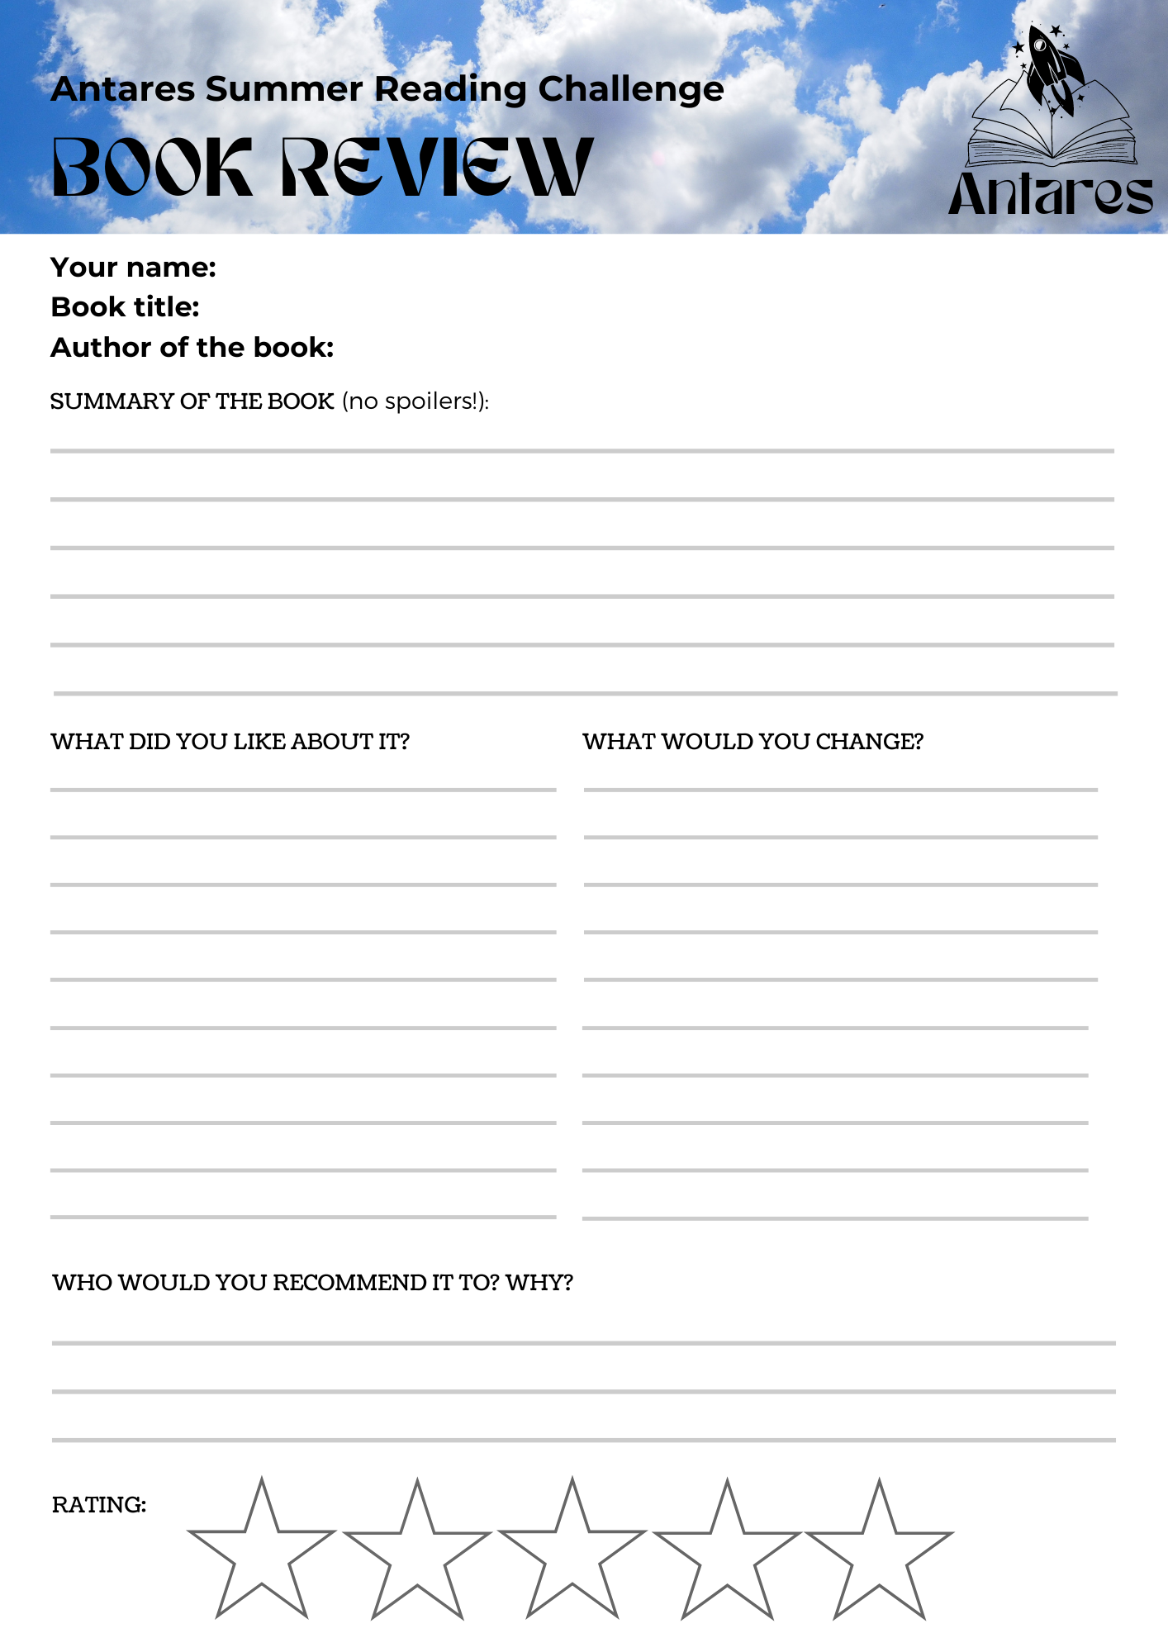



Answer here…

Answer here…

Answer here…

Enter your plot summary here…